Introduction to Smart Disaster Management

Smart disaster management is the modern approach to handling disasters by integrating advanced technologies, data analytics, and digital communication systems into traditional disaster management practices. It focuses on using tools such as Artificial Intelligence (AI), the Internet of Things (IoT), Geographic Information Systems (GIS), drones, and satellite communication to predict, prepare for, respond to, and recover from disasters more efficiently.
In today’s world, where natural and man-made disasters are becoming more frequent and intense due to climate change and urbanization, smart disaster management plays a crucial role in minimizing damage and saving lives. By enabling real-time monitoring, early warning systems, and quick data-driven decision-making, it transforms the way governments, organizations, and communities respond to emergencies.
Ultimately, smart disaster management represents a shift from reactive to proactive disaster response, aiming to build safer, more resilient, and better-prepared societies for the future.

Objectives:
- To provide real-time disaster alerts to citizens and authorities.
- To create a centralized digital platform for managing all disaster-related information.
- To support quick decision-making during emergencies.
- To help rescue teams with features like location tracking, resource management, and communication tools.
- To store and analyze past disaster data for future prediction and planning.

Tools Platform Hardware and Software Requirements

Software Requirements:
- Programming Language: JavaScript
- Front-end: HTML, CSS, JavaScript,
- Database: MySQL
- Operating System: Windows, Mac
- APIs: Google Maps API,

Hardware Requirements:
- Standard PC or Laptop
- Internet Connectivity
- GPS-enabled Mobile Devices (for testing alert and tracking features)

Software Design (Frontend, Backend, Database)
The software design of the Smart IoT-based Disaster Management System is organized into three major layers: frontend, backend, and database. Together, these layers ensure that sensor data received from the IoT hardware is stored securely, processed correctly, and presented to users in a clear, interactive, and real-time manner through a web dashboard. The design follows a typical web application architecture where the browser interacts with the backend via HTTP/HTTPS requests, and the backend communicates with the database and IoT device endpoints.
- Frontend design
The frontend is responsible for the user interface (UI) and overall user experience (UX) of the system. It is implemented using HTML for structure, CSS for styling and layout, and JavaScript for interactivity and dynamic content updates. The main objective of the frontend is to provide a responsive, easy-to-understand dashboard where users can monitor real-time environmental parameters, view historical trends, and check alert status for different disaster-related indicators such as rainfall, water level, temperature, and soil moisture.
Key frontend components typically include:
• Login and authentication page: A simple login screen allows authorized users (e.g., administrators, operators) to access the dashboard using a username and password. Basic form validation is done on the client side using JavaScript before sending the credentials to the backend.
• Main dashboard page: After login, the user sees a central dashboard that shows current sensor readings, last updated time, and status indicators for each monitored parameter. Color-coded cards or panels (green for normal, yellow for warning, red for danger) are used to reflect threshold-based conditions clearly.
• Real-time data widgets and charts: JavaScript libraries or custom code can be used to periodically poll the backend (via AJAX or fetch API) to update readings without reloading the page. Line charts or bar graphs display historical trends over selected time intervals, helping users observe patterns such as rising water level or increasing soil moisture.
• Alerts and notifications section: The frontend also includes a section where active or past alerts are listed with details like parameter, threshold exceeded, time of alert, and notification status. This helps in tracking when and why alerts were triggered.
The UI is designed to be responsive so that it works on desktops, laptops, and mobile devices, using CSS media queries or frameworks if desired. Clear navigation menus or tabs separate pages like “Dashboard,” “Sensor Logs,” “Settings,” and “User Management” to keep the interface organized and intuitive.
Backend design
The backend acts as the logical core of the system. It is implemented using a server-side technology such as PHP or Node.js and exposes endpoints (APIs) for both the IoT device and the frontend web application. The backend has three main responsibilities: receiving and storing sensor data, applying business logic (threshold checks and alert generation), and serving data and pages to users.
Main backend modules include:
• Data ingestion API: The IoT hardware (Arduino + ESP8266) sends sensor readings to a specific URL (e.g., a PHP script or Node.js route) using HTTP GET or POST requests. This module authenticates the request if needed (e.g., using an API key), parses the incoming payload (sensor values, timestamps, device ID), validates data ranges, and then saves it to the database.
• Business logic and threshold evaluation: Once data is received, the backend compares sensor values against predefined thresholds stored in configuration files or database tables. If a value crosses a warning or danger level, the backend updates the status field and triggers alert logic. This can include sending SMS via an SMS gateway API or sending emails using SMTP or email service providers.
• User authentication and authorization: The backend validates login credentials against stored user records and creates sessions or tokens for authenticated users. It controls access to restricted pages and API routes to ensure only authorized users can view or modify system settings.
• Data retrieval services: The backend provides endpoints for the frontend to request data in JSON or HTML format. These include APIs for latest sensor readings, historical data over a time range, alert logs, and configuration parameters. The frontend uses these APIs to populate tables and charts dynamically.
The backend is typically deployed on a cloud hosting platform (such as Thing Speak, Firebase, or AWS in combination with a web server) and configured to run continuously, handle multiple requests, and log errors for maintenance. Basic security measures, such as input validation and protection against SQL injection, are included in the backend design.
Data base designe
The database design uses a relational database management system like MySQL to store all persistent data, including sensor readings, user information, thresholds, and alert logs. Proper schema design is crucial for performance, maintainability, and accurate reporting.
Typical tables in the database include:
• Users table: Stores user_id, username, password hash, role (e.g., admin, operator), and contact details such as email and phone number. This table supports authentication and role-based access control.
• Sensors or devices table: Contains details about each sensor or IoT node, such as sensor_id, type (rain, water level, temperature, soil moisture), location description, and current status. This helps identify where data originates and supports future scaling to multiple nodes.
• Sensor_readings table: This is the core table that stores real-time data. Fields typically include reading_id, sensor_id, timestamp, value, unit, and status (normal, warning, danger). Indexing on timestamp and sensor_id allows efficient querying for graphs and reports.
• Alerts table: Records each alert event with fields like alert_id, sensor_id, timestamp, measured_value, threshold_type, alert_message, and notification_status (e.g., SMS sent, email sent). This log is useful for auditing and analyzing system performance.

Data Flow Diagram (DFD)
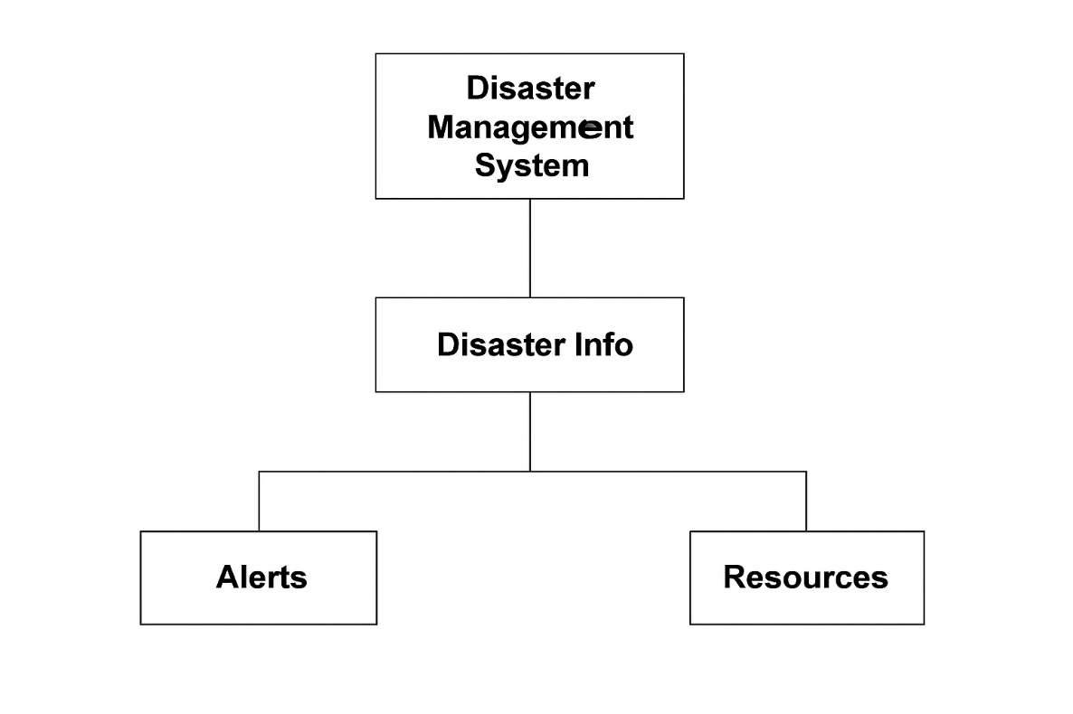
- Level 0: Disaster Management System (Input: Sensor data, Manual alerts → Output: Notifications, Reports)

- Level 1:
  - Disaster Detection
  - User Management
  - Alert System
  - Resource Allocation
  - Reporting Module
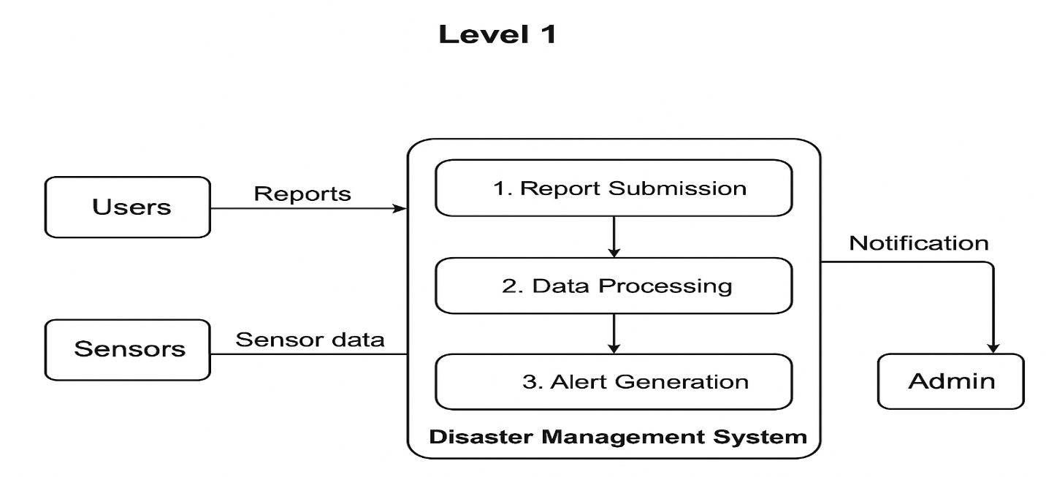
- Level 2: Detailed flows for:
  - Data collection
  - Alert generation
  - Rescue team assignment
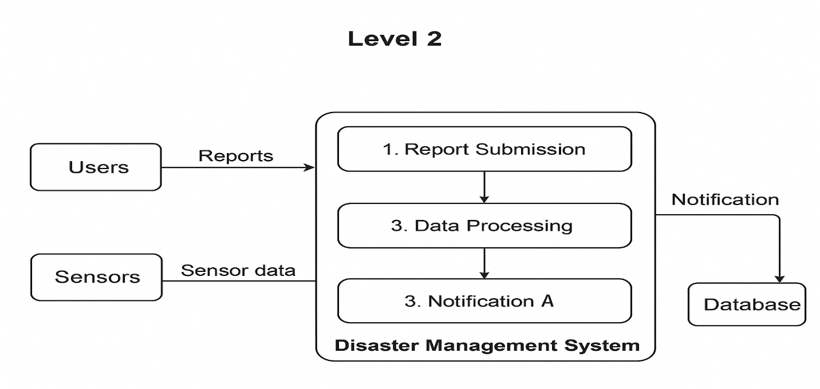
  - Citizen help request management

ER Diagram Includes:
- Users
- Admin
- Rescue Teams
- Disaster Types
- Alerts
- Locations
- Resources
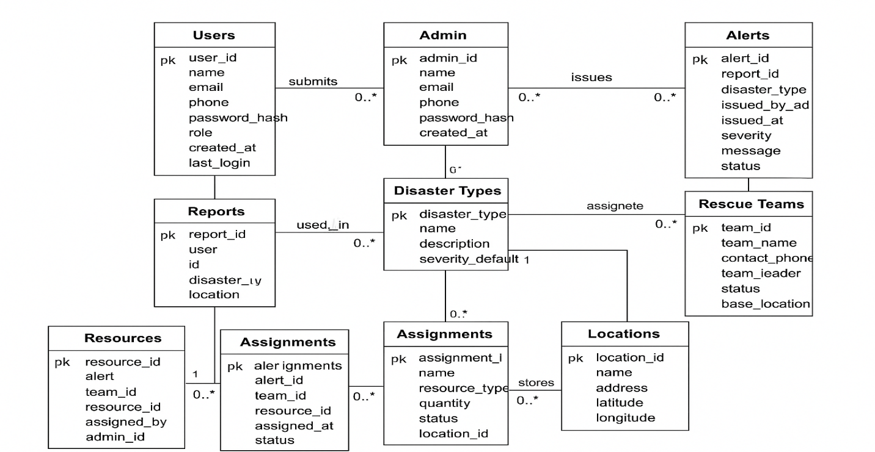
- Reports

Class Diagram (If using OOPS):
- User Class
- Admin Clas
- Disaster Class
- Alert Class
- Resource Class
- Report Class
- Location Class
Database Design
- Tables: Users, Disaster Info, Alerts, Resources, Rescue Teams, Reports, Locations.
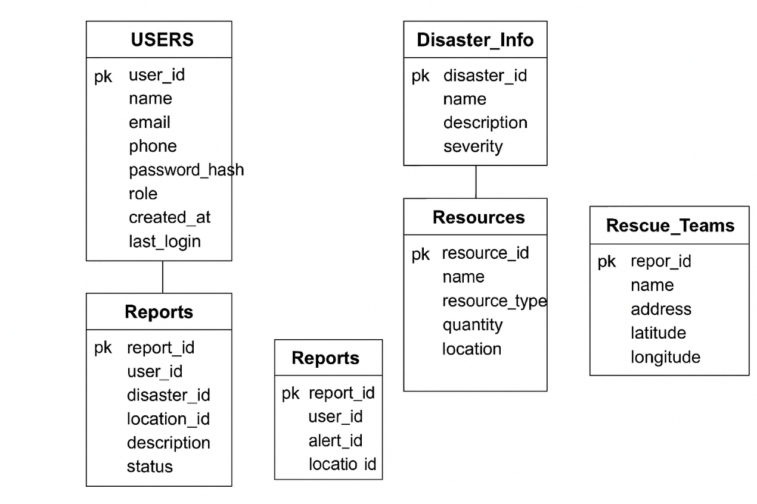

Limitations:
- Accuracy depends on availability of API data.
- Requires stable internet connectivity.
- High cost if connected to real-time IoT devices.
- Large-scale deployment requires government support.

Code
Index.html
<!DOCTYPE html>
<html lang="en">
<head>
<meta charset="UTF-8">
<meta name="viewport" content="width=device-width, initial-scale=1.0">
<title>Smart Disaster Management System - Uttarakhand</title>
<link rel="stylesheet" href="style.css">
<link rel="stylesheet" href="https://unpkg.com/leaflet/dist/leaflet.css" />
</head>
<body>
<section id="home" class="container">
<!-- Hero Section -->
<div class="hero">
<div class="hero-content">
<h1>Smart Disaster Management System (Uttarakhand)</h1>
<p>Stay Informed, Stay Safe. Your gateway to real-time disaster alerts and resources.</p> <button class="hero-btn" onclick="scrollToDashboard()">Get Started</button>
</div>
</div>
<marquee scrollamount="4" id="topMarquee" onmouseover="this.setAttribute('scrollamount', 0, 0); document.getElementById('topMarquee').stop();" onmouseout="this.setAttribute('scrollamount', 4, 0); document.getElementById('topMarquee').start();" style="border: 2px solid #444; border-radius: 5px; padding: 5px;">
<div class="region region-highlights">
<div id="block-block-8" class="block block-block first last odd">
<p>Saving Lives &amp; Beyond “आपदा सेवा सदैव सर्वत्र” NDRF Helpline Number : +91-9711077372 Saving Lives &amp; Beyond “आपदा सेवा सदैव सर्वत्र” NDRF Helpline Number : +91-9711077372 Saving Lives &amp; Beyond “आपदा सेवा सदैव सर्वत्र” NDRF Helpline Number : +91-9711077372 Saving Lives &amp; Beyond “आपदा सेवा सदैव सर्वत्र”</p>
</div>
</div>
</marquee> <!-- Navbar -->
<nav> <a href="#home">🏠</a> <a href="map.html">Map</a> <a href="alerts.html" class="active">Alerts</a> <a href="report.html" class="active">🚨 Report Incident</a> <a href="resources.html" class="active">Resources</a> <a href="photo-gallery.html">📸 Photo Gallery</a> <a href="about.html">About</a> <a href="admin.html">Login</a> <button id="theme-toggle" class="theme-toggle-btn">🌙</button> </nav>
<marquee behavior="scroll" direction="left" scrollamount="15">
<div class="sos-buttons"> <button class="so’s" onclick="triggerSOS()">🆘 SOS</button> <button class="helpline" onclick="showHelplines()">☎️ Helplines</button> <button class="route" onclick="findSafeRoute()">🛣️ Safe Route</button> </div>
</marquee> <!-- Quick Actions and Photo Gallery -->
<div class="actions-gallery-container">
<!-- Quick Actions -->
<section class="quick-actions">
<h2>Quick Actions</h2>
<p>Take immediate steps to stay safe during emergencies.</p>
<div class="action-buttons"> <button onclick="window.location.href='shelter.html'">🏠 Find Shelter</button> <button onclick="showHelplines()">📞 Helplines</button> </div>
</section> <!-- Rotating Photo Gallery -->
<section class="photo-gallery">
<h2>Disaster Awareness Gallery</h2>
<div class="gallery-container"> <img src="Disaster Awareness Gallery/d1.gif" alt="Disaster Awareness 1" class="gallery-image active"> <img src="Disaster Awareness Gallery/d2.avif" alt="Disaster Awareness 2" class="gallery-image"> <img src="Disaster Awareness Gallery/d3.jpg" alt="Disaster Awareness 3" class="gallery-image"> <img src="Disaster Awareness Gallery/d4.jpg" alt="Disaster Awareness 4" class="gallery-image"> <img src="Disaster Awareness Gallery/d5.jpg" alt="Disaster Awareness 5" class="gallery-image"> <img src="uploads/download (2).jpg" alt="Disaster Awareness 6" class="gallery-image"> </div>
</section>
</div> <!-- Home/Dashboard -->
<div class="dashboard">
<div class="card">
<h2>Active Alerts</h2>
<ul id="alerts-list">
<li>⚠️ Flash Flood Warning - Uttarkashi (Sep 2025)</li>
<li>⚠️ Landslide Risk - Gangotri Highway</li>
</ul>
</div>
<div class="card">
<h2>Recent Incidents</h2>
<ul>
<li>✅ Aug 2025: Cloudburst in Barkot, 3 rescued</li>
<li>✅ Jul 2025: Landslide blocked Gangotri road</li>
</ul>
</div>
<div class="card">
<h2>Disaster Statistics</h2>
<ul id="disaster-stats">
<li>🌧️ Floods: 45 incidents this year</li>
<li>🏔️ Landslides: 28 reported</li>
<li>☁️ Cloudbursts: 12 events</li>
<li>🌋 Earthquakes: 5 events</li>
<li>🔥 Wildfires: 8 incidents</li>
<li>🌪️ Cyclones: 3 events</li>
<li>👥 People Affected: 2,500+</li>
</ul>
</div>
<div class="card">
<h2>Government Helplines</h2>
<ul>
<li>📞 NDMA: 011-26701700</li>
<li>📞 Uttarakhand SDMA: 0135-2710334</li>
<li>📞 State Control Room: 1070</li>
<li>🚒 Fire Services: 101</li>
<li>🚔 Police: 100</li>
</ul>
</div>
<div class="card">
<h2>Live Sensor Data</h2>
<ul>
<li>🌱 Soil Moisture: <span id="moisture-value">--</span></li>
<li>🌧️ Rain Status: <span id="rain-value">--</span></li>
<li>💧 Water Level: <span id="water-level-value">--</span></li>
<li>🌡️ Temperature: <span id="temperature-value">--</span></li>
<li>💨 Humidity: <span id="humidity-value">--</span></li>
<li>🏔️ Earthquake: <span id="earthquake-value">--</span></li>
<li>🏔️ Landslide Risk: <span id="landslide-value">--</span></li>
<li>🔥 Wildfire Risk: <span id="wildfire-value">--</span></li>
<li>🌪️ Cyclone Wind Speed: <span id="cyclone-value">--</span></li>
</ul>
<p id="sensor-timestamp" style="font-size: 12px; color: #666; margin-top: 10px;">Loading...</p>
</div>
</div>
</section> <!-- Official Government Websites -->
<section id="government-links" class="container">
<h2>Official Government Websites</h2>
<div class="gov-links-grid">
<div class="gov-link-card">
<h3>🇮🇳 National Disaster Management Authority (NDMA)</h3>
<p>Central authority for disaster management in India.</p> <a href="https://ndma.gov.in/" target="_blank">Visit Website</a>
</div>
<div class="gov-link-card">
<h3>🌤️ Indian Meteorological Department (IMD)</h3>
<p>Weather forecasts and meteorological services.</p> <a href="https://mausam.imd.gov.in/" target="_blank">Visit Website</a>
</div>
<div class="gov-link-card">
<h3>🏛️ Uttarakhand Government</h3>
<p>Official website of the Uttarakhand Government.</p> <a href="https://uk.gov.in/" target="_blank">Visit Website</a>
</div>
</div>
</section> <!-- Footer -->
<footer>
<div class="footer-content">
<div class="footer-section">
<h3>Contact Us</h3>
<p><a href="mailto:info@uttarakhanddisaster.gov.in">📧 info@uttarakhanddisaster.gov.in</a></p>
<p><a href="tel:+91-135-2710334">📞 +91-135-2710334</a></p>
</div>
<div class="footer-section">
<h3>Follow Us</h3>
<p>🔗 <a href="https://www.facebook.com/UttarakhandGov" target="_blank">Facebook</a> | <a href="https://twitter.com/uttarakhandgov" target="_blank">Twitter</a> | <a href="https://www.instagram.com/uttarakhandgov/" target="_blank">Instagram</a></p>
</div>
<div class="footer-section">
<h3>Quick Links</h3>
<p><a href="map.html">Map</a> | <a href="alerts.html">Alerts</a> | <a href="report.html">Report</a></p>
</div>
</div>
<div class="creators" style="text-align: center;">
<p>Website Created by: Gautam Bijalwan, Prashant Ramola, Gauri Semwal</p>
<p>Roles by: Shivom Rana & Hemant</p>
<p> Mentor: shivom bhatt</p>
</div>
<div class="footer-bottom">
<p>&copy; 2025 Smart Disaster Management System - Uttarakhand. All rights reserved.</p>
</div>
</footer>
<script src="https://unpkg.com/leaflet/dist/leaflet.js"></script>
<script src="script.js"></script>
</body>
</html>

Map.html

<!DOCTYPE html>
<html lang="en">

<head>
<meta charset="UTF-8">
<title>Disaster-Prone Districts Map</title>
<link rel="stylesheet" href="style.css">
<link rel="stylesheet" href="https://unpkg.com/leaflet/dist/leaflet.css" />
<script src="https://unpkg.com/leaflet/dist/leaflet.js"></script>
<script src="script.js" defer></script>
</head>

<body>
<marquee scrollamount="4" id="topMarquee" onmouseover="this.setAttribute('scrollamount', 0, 0); document.getElementById('topMarquee').stop();" onmouseout="this.setAttribute('scrollamount', 4, 0); document.getElementById('topMarquee').start();" style="border: 2px solid #444; border-radius: 5px; padding: 5px;">

<div class="region region-highlights">
<div id="block-block-8" class="block block-block first last odd">

<p>Saving Lives &amp; Beyond “आपदा सेवा सदैव सर्वत्र” NDRF Helpline Number : +91-9711077372 Saving Lives &amp; Beyond “आपदा सेवा सदैव सर्वत्र” NDRF Helpline Number : +91-9711077372 Saving Lives &amp; Beyond “आपदा सेवा सदैव सर्वत्र” NDRF Helpline Number : +91-9711077372 Saving Lives &amp; Beyond “आपदा सेवा सदैव सर्वत्र”</p>

</div>
</div>
</marquee>

<header>
<h1>Disaster-Prone Districts - Uttarakhand</h1>
<nav>
<a href="index.html">Home</a>
<a href="map.html" class="active">Map</a>
<a href="report.html">Report Incident</a>
<a href="resources.html">Resources</a>
<a href="admin.html">Admin</a>
<button id="theme-toggle" class="theme-toggle-btn">🌙</button>
</nav>
</header>
<section>
<div id="map"></div>
</section>
<!-- Map -->
<section id="map" class="container">
<h1 style="float: center;">Disaster-Prone Districts Map</h1>

<select id="districtSelect" onchange="goToDistrict()">
<option value="">-- Select District --</option>
<option value="30.73,78.44">Uttarkashi</option>
<option value="30.31,78.03">Dehradun</option>
<option value="30.41,78.03">Chamoli</option>
<option value="30.28,78.98">Rudraprayag</option>
<option value="30.39,78.48">Tehri Garhwal</option>
<option value="29.58,78.78">Pithoragarh</option>
<option value="30.15,80.22">Pauri Garhwal</option>
<option value="29.38,79.45">Almora</option>
<option value="29.83,79.78">Bageshwar</option>
<option value="29.33,79.65">Champawat</option>
<option value="29.92,78.07">Haridwar</option>
<option value="29.38,79.45">Nainital</option>
<option value="29.02,79.48">Udham Singh Nagar</option>
</select>

<br>
<!-- Map container -->
<div id="mapid"></div>
</section>

<style>
/* Styling for the map */
#mapid {
height: 600px;
/* smaller height */
width: 100%;
/* smaller width */
margin: 15px auto;
border: 2px solid #444;
border-radius: 10px;
float: left;
}
</style>
</body>

</html>

Alerts
<!DOCTYPE html>
<html lang="en">

<head>
<meta charset="UTF-8">
<meta name="viewport" content="width=device-width, initial-scale=1.0">
<title>Active Alerts - Uttarakhand Disaster Management</title>
<link rel="stylesheet" href="style.css">
</head>

<body>
<header>
<h1>Active Alerts - Uttarakhand</h1>
<nav>
<a href="index.html">Home</a>
<a href="map.html">Map</a>
<a href="alerts.html" class="active">Alerts</a>
<a href="report.html">Report Incident</a>
<a href="resources.html">Resources</a>
<a href="admin.html">Admin</a>
<button id="theme-toggle" class="theme-toggle-btn">🌙</button>
</nav>
</header>

<section class="container">
<h2>Current Disaster Alerts</h2>
<div class="alerts-list">
<div class="alert-card">
<h3>⚠️ Flash Flood Warning - Uttarkashi</h3>
<p><strong>Date:</strong> September 2025</p>
<p><strong>Description:</strong> Heavy rainfall expected in the region. Rivers may overflow. Evacuate low-lying areas immediately.</p>
<p><strong>Advice:</strong> Move to higher ground, avoid crossing flooded areas, stay tuned for updates.</p>
</div>
<div class="alert-card">
<h3>⚠️ Landslide Risk - Gangotri Highway</h3>
<p><strong>Date:</strong> Ongoing</p>
<p><strong>Description:</strong> Increased landslide activity due to recent seismic activity. Road closures possible.</p>
<p><strong>Advice:</strong> Avoid travel on affected highways, follow detour signs, monitor local news.</p>
</div>
<div class="alert-card">
<h3>⚠️ Cloudburst Alert - Chamoli District</h3>
<p><strong>Date:</strong> August 2025</p>
<p><strong>Description:</strong> Sudden heavy rain leading to flash floods in mountainous areas.</p>
<p><strong>Advice:</strong> Seek shelter indoors, avoid outdoor activities, prepare emergency kits.</p>
</div>
</div>

<h2>How to Respond to Alerts</h2>
<ul>
<li>Stay informed through official channels.</li>
<li>Follow evacuation orders promptly.</li>
<li>Prepare an emergency kit with essentials.</li>
<li>Contact helplines: 108 (Medical), 112 (Emergency), 1070 (State Control Room).</li>
</ul>

<h2>Subscribe for Alerts</h2>
<form id="subscribeForm">
<input type="email" placeholder="Enter your email" required>
<button type="submit">Subscribe</button>
</form>
</section>

<footer>
<div class="footer-content">
<div class="footer-section">
<h3>Contact Us</h3>
<p>📧 info@uttarakhanddisaster.gov.in</p>
<p>📞 +91-135-2710334</p>
</div>
<div class="footer-section">
<h3>Follow Us</h3>
<p>🔗 <a href="#">Facebook</a> | <a href="#">Twitter</a> | <a href="#">Instagram</a></p>
</div>
<div class="footer-section">
<h3>Quick Links</h3>
<p><a href="map.html">Map</a> | <a href="alerts.html">Alerts</a> | <a href="report.html">Report</a></p>
</div>
</div>
<div class="footer-bottom">
<p>&copy; 2025 Smart Disaster Management System - Uttarakhand. All rights reserved.</p>
</div>
</footer>

<script src="script.js"></script>
</body>
</html>

Report
<!DOCTYPE html>
<html lang="en">
<head>
<meta charset="UTF-8">
<title>Report an Incident</title>
<link rel="stylesheet" href="style.css">
<script src="script.js" defer></script>
</head>
<body>
<header>
<h1>Report a Disaster Incident</h1>
<nav>
<a href="index.html">Home</a>
<a href="map.html">Map</a>
<a href="report.html" class="active">Report</a>
<a href="resources.html">Resources</a>
<a href="admin.html">Admin</a>
<button id="theme-toggle" class="theme-toggle-btn">🌙</button>
</nav>
</header>

<main class="report-container">
<div class="chat-section">
<h3>💬 Chat Support</h3>
<div id="chat-messages" class="chat-messages"></div>
<div class="chat-input">
<input type="text" id="chat-input" placeholder="Type your message..." />
<button id="send-chat">Send</button>
</div>
</div>
<div class="form-section">
<h2>🚨 Report a Disaster Incident</h2>
<form id="incidentForm">
<div class="form-group">
<label for="name">👤 Your Name</label>
<input type="text" id="name" name="name" placeholder="Enter your full name" required>
</div>
<div class="form-group">
<label for="location">📍 Location</label>
<input type="text" id="location" name="location" placeholder="Enter the location" required>
</div>
<div class="form-group">
<label for="disasterType">🌪️ Disaster Type</label>
<select id="disasterType" name="disasterType" required>
<option value="">Select Disaster Type</option>
<option>🌊 Flood</option>
<option>🏔️ Landslide</option>
<option>☁️ Cloudburst</option>
</select>
</div>
<div class="form-group">
<label for="description">📝 Description</label>
<textarea id="description" name="description" placeholder="Describe the situation in detail..." required></textarea>
</div>
<div class="form-group">
<label for="image">📸 Upload Image (Optional)</label>
<input type="file" id="image" name="image" accept="image/*">
</div>
<button type="submit" class="submit-btn">🚀 Submit Report</button>
</form>
</div>
</main>

<footer>Help authorities respond faster — report accurately.</footer>
</body>
</html>

Resources
<!DOCTYPE html>
<html lang="en">

<head>
<meta charset="UTF-8">
<meta name="viewport" content="width=device-width, initial-scale=1.0">
<title>Safety Tips & Resources - Uttarakhand Disaster Management</title>
<link rel="stylesheet" href="style.css">
</head>

<body>
<header>
<h1>Safety Tips & Resources</h1>
<nav>
<a href="index.html">Home</a>
<a href="map.html">Map</a>
<a href="alerts.html">Alerts</a>
<a href="report.html">Report Incident</a>
<a href="resources.html" class="active">Resources</a>
<a href="admin.html">Admin</a>
<button id="theme-toggle" class="theme-toggle-btn">🌙</button>
</nav>
</header>

<section class="container">
<h2>Disaster Preparedness & Safety Tips</h2>
<div class="tips-grid">
<div class="tip-card">
<h3>🌧️ Flood Safety</h3>
<p>Move to higher ground immediately. Avoid walking or driving through floodwaters. Never underestimate the power of moving water.</p>
</div>
<div class="tip-card">
<h3>🏔️ Landslide Prevention</h3>
<p>Stay alert near hilly terrain. Evacuate if signs of movement appear. Avoid building or living near steep slopes.</p>
</div>
<div class="tip-card">
<h3>☁️ Cloudburst Response</h3>
<p>Seek shelter immediately. Avoid low-lying areas prone to flash floods. Stay indoors until the rain stops.</p>
</div>
<div class="tip-card">
<h3>❄️ Avalanche Awareness</h3>
<p>In snowy regions, avoid steep slopes. Carry avalanche beacons if venturing out. Travel with experienced guides.</p>
</div>
<div class="tip-card">
<h3>🌍 Earthquake Readiness</h3>
<p>Drop, Cover, and Hold On. Stay indoors until shaking stops. Secure heavy furniture and objects.</p>
</div>
<div class="tip-card">
<h3>🎒 Emergency Kit Essentials</h3>
<p>Keep water, torch, medicines, non-perishable food, first aid kit, and important documents ready.</p>
</div>
<div class="tip-card">
<h3>📞 Emergency Contacts</h3>
<p>Call 108 for medical emergencies, 112 for general assistance, 1070 for state control room.</p>
</div>
<div class="tip-card">
<h3>🚨 Community Preparedness</h3>
<p>Know your area's disaster risks. Participate in drills and community training. Help neighbors in need.</p>
</div>
<div class="tip-card">
<h3>🏕️ Trekking Safety</h3>
<p>Inform someone about your plans. Carry GPS device. Check weather forecasts. Avoid trekking alone.</p>
</div>
<div class="tip-card">
<h3>🚗 Vehicle Safety</h3>
<p>Carry extra fuel, water, and blankets. Avoid driving during heavy rain or landslides. Use chains in snow.</p>
</div>
<div class="tip-card">
<h3>🏠 Home Preparation</h3>
<p>Reinforce your home against disasters. Keep emergency supplies for at least 72 hours. Have a family emergency plan.</p>
</div>
<div class="tip-card">
<h3>👨‍👩‍👧‍👦 Family Communication</h3>
<p>Designate a meeting point. Teach children emergency procedures. Keep a list of important contacts.</p>
</div>
</div>

<h2>Useful Resources</h2>
<div class="resources-list">
<div class="resource-item">
<h3>📚 Government Websites</h3>
<ul>
<li><a href="#">Uttarakhand Disaster Management Authority</a></li>
<li><a href="#">National Disaster Management Authority (NDMA)</a></li>
<li><a href="#">Indian Meteorological Department</a></li>
</ul>
</div>
<div class="resource-item">
<h3>📱 Mobile Apps</h3>
<ul>
<li>Disaster Management App (Android/iOS)</li>
<li>Weather Forecast Apps</li>
<li>Emergency SOS Apps</li>
</ul>
</div>
<div class="resource-item">
<h3>📖 Educational Materials</h3>
<ul>
<li>Disaster Preparedness Guide</li>
<li>First Aid Training Manuals</li>
<li>Survival Skills Workshops</li>
</ul>
</div>
<div class="resource-item">
<h3>🏥 Medical Facilities</h3>
<ul>
<li>Government Hospitals</li>
<li>Emergency Medical Services</li>
<li>Helicopter Evacuation Services</li>
</ul>
</div>
</div>

<h2>Download Resources</h2>
<div class="downloads">
<button onclick="downloadGuide()">📄 Disaster Preparedness Guide (PDF)</button>
<button onclick="downloadChecklist()">✅ Emergency Checklist (PDF)</button>
<button onclick="downloadMap()">🗺️ District Risk Map (PDF)</button>
</div>
</section>

<footer>
<div class="footer-content">
<div class="footer-section">
<h3>Contact Us</h3>
<p>📧 info@uttarakhanddisaster.gov.in</p>
<p>📞 +91-135-2710334</p>
</div>
<div class="footer-section">
<h3>Follow Us</h3>
<p>🔗 <a href="#">Facebook</a> | <a href="#">Twitter</a> | <a href="#">Instagram</a></p>
</div>
<div class="footer-section">
<h3>Quick Links</h3>
<p><a href="map.html">Map</a> | <a href="alerts.html">Alerts</a> | <a href="report.html">Report</a></p>
</div>
</div>
<div class="footer-bottom">
<p>&copy; 2025 Smart Disaster Management System - Uttarakhand. All rights reserved.</p>
</div>
</footer>

<script src="script.js"></script>
</body>

</html>

Photo-gallery
<!DOCTYPE html>
<html lang="en">

<head>
<meta charset="UTF-8">
<meta name="viewport" content="width=device-width, initial-scale=1.0">
<title>Photo Gallery - Smart Disaster Management System - Uttarakhand</title>
<link rel="stylesheet" href="style.css">
</head>

<body>

<section id="home" class="container">

<!-- Hero Section -->
<div class="hero photo-gallery-hero">
<h1>Disaster Awareness Photo Gallery</h1>
<p>Visual insights into disaster preparedness and response in Uttarakhand.</p>
</div>

<!-- Navbar -->
<nav>
<a href="index.html">Home</a>
<a href="map.html">Map</a>
<a href="alerts.html">Alerts</a>
<a href="report.html">Report Incident</a>
<a href="resources.html">Resources</a>
<a href="photo-gallery.html" class="active">Photo Gallery</a>
<a href="about.html">About</a>
<a href="admin.html">Login</a>
<button id="theme-toggle" class="theme-toggle-btn">🌙</button>
</nav>

<!-- Photo Gallery -->
<section id="photo-gallery" class="container">
<h2>Photo Gallery</h2>

<!-- Mentorship Section -->
<h3>Mentorship</h3>
<div class="gallery-grid">
<img src="image/20251027_151250.jpg" alt="20251027_151250" title="Mentorship" onclick="openLightbox(this)">
<img src="image/20251027_151314.jpg" alt="20251027_151314" title="Leadership" onclick="openLightbox(this)">
<img src="image/20251027_151341.jpg" alt="20251027_151341" title="inspection" onclick="openLightbox(this)">
<img src="image/20251027_151349.jpg" alt="20251027_151349" title="Preview" onclick="openLightbox(this)">
<img src="image/20251027_151434.jpg" alt="20251027_151434" title="Motivating." onclick="openLightbox(this)">
</div>

<!-- Disaster and Rescue Section -->
<h3>Disaster and rescue</h3>
<div class="gallery-grid">
<img src="image/Bridge collapses on gangotri hioghway.avif" alt="Bridge collapses on Gangotri highway" title="Gaumukh glacier region — source of the Ganga River." onclick="openLightbox(this)">
<img src="image/gaumukh.jpg" alt="Gaumukh" onclick="openLightbox(this)">
<img src="image/nalupani landslide.jpg" alt="Nalupani landslide" onclick="openLightbox(this)">
<img src="image/Rescue mission during cloudburst.avif" alt="Rescue mission during cloudburst" onclick="openLightbox(this)">
<img src="image/silkyara tunnel collpes.avif" alt="Silkyara tunnel collapse" onclick="openLightbox(this)">

</div>

<!-- Lightbox -->
<div id="lightbox" class="lightbox" onclick="closeLightbox()">
<img id="lightbox-img" src="" alt="">
</div>
</section>

<!-- Footer -->
<footer>
<div class="footer-content">
<div class="footer-section">
<h3>Contact Us</h3>
<p><a href="mailto:info@uttarakhanddisaster.gov.in">📧 info@uttarakhanddisaster.gov.in</a></p>
<p><a href="tel:+91-135-2710334">📞 +91-135-2710334</a></p>
</div>
<div class="footer-section">
<h3>Follow Us</h3>
<p>🔗 <a href="https://www.facebook.com/UttarakhandGov" target="_blank">Facebook</a> | <a href="https://twitter.com/uttarakhandgov" target="_blank">Twitter</a> | <a href="https://www.instagram.com/uttarakhandgov/" target="_blank">Instagram</a></p>
</div>
<div class="footer-section">
<h3>Quick Links</h3>
<p><a href="map.html">Map</a> | <a href="alerts.html">Alerts</a> | <a href="report.html">Report</a></p>
</div>
</div>
<div class="footer-bottom">
<p>&copy; 2025 Smart Disaster Management System - Uttarakhand. All rights reserved.</p>
</div>
</footer>

<script src="script.js"></script>
</body>

</html>

About
<!DOCTYPE html>
<html lang="en">

<head>
<meta charset="UTF-8">
<meta name="viewport" content="width=device-width, initial-scale=1.0">
<title>About - Smart Disaster Management System - Uttarakhand</title>
<link rel="stylesheet" href="style.css">
</head>

<body>

<section id="home" class="container">

<!-- Hero Section -->
<div class="hero">
<h1>About Us</h1>
<p>Learn more about the Smart Disaster Management System for Uttarakhand.</p>
</div>

<!-- Navbar -->
<nav>
<a href="index.html">Home</a>
<a href="map.html">Map</a>
<a href="alerts.html">Alerts</a>
<a href="report.html">Report Incident</a>
<a href="resources.html">Resources</a>
<a href="photo-gallery.html">Photo Gallery</a>
<a href="about.html" class="active">About</a>
<a href="admin.html">Login</a>
<button id="theme-toggle" class="theme-toggle-btn">🌙</button>
</nav>

<!-- About Section -->
<section id="about" class="container">
<h2>About the Smart Disaster Management System</h2>
<p>The Smart Disaster Management System for Uttarakhand is designed to provide real-time disaster alerts, resources, and support to residents and visitors in the state. Our platform integrates advanced technology to ensure timely information dissemination and effective response to natural disasters such as floods, landslides, and cloudbursts.</p>

<h3>Our Mission</h3>
<p>To save lives and minimize damage by providing accurate, timely, and accessible disaster management information to the people of Uttarakhand.</p>

<h3>Key Features</h3>
<ul>
<li>Real-time disaster alerts and warnings</li>
<li>Interactive maps showing risk areas</li>
<li>Incident reporting system</li>
<li>Emergency helplines and resources</li>
<li>Disaster preparedness guides and checklists</li>
<li>Photo gallery for awareness</li>
</ul>

<h3>Contact Information</h3>
<p>For more information, please contact us at:</p>
<p>Email: <a href="mailto:info@uttarakhanddisaster.gov.in">info@uttarakhanddisaster.gov.in</a></p>
<p>Phone: <a href="tel:+91-135-2710334">+91-135-2710334</a></p>
</section>

<!-- Footer -->
<footer>
<div class="footer-content">
<div class="footer-section">
<h3>Contact Us</h3>
<p><a href="mailto:info@uttarakhanddisaster.gov.in">📧 info@uttarakhanddisaster.gov.in</a></p>
<p><a href="tel:+91-135-2710334">📞 +91-135-2710334</a></p>
</div>
<div class="footer-section">
<h3>Follow Us</h3>
<p>🔗 <a href="https://www.facebook.com/UttarakhandGov" target="_blank">Facebook</a> | <a href="https://twitter.com/uttarakhandgov" target="_blank">Twitter</a> | <a href="https://www.instagram.com/uttarakhandgov/" target="_blank">Instagram</a></p>
</div>
<div class="footer-section">
<h3>Quick Links</h3>
<p><a href="map.html">Map</a> | <a href="alerts.html">Alerts</a> | <a href="report.html">Report</a></p>
</div>
</div>
<div class="footer-bottom">
<p>&copy; 2025 Smart Disaster Management System - Uttarakhand. All rights reserved.</p>
</div>
</footer>

</body>

</html>

Admin-dashboard
<!DOCTYPE html>
<html lang="en">

<head>
<meta charset="UTF-8">
<meta name="viewport" content="width=device-width, initial-scale=1.0">
<title>Admin Dashboard - Smart Disaster Management System</title>
<link rel="stylesheet" href="style.css">
</head>

<body>
<header>
<h1>Admin Dashboard</h1>
<nav>
<a href="index.html">Home</a>
<a href="admin.html" onclick="logout()">Logout</a>
<button id="theme-toggle" class="theme-toggle-btn">🌙</button>
</nav>
</header>

<section class="container">
<h2>Dashboard Overview</h2>
<div class="dashboard">
<div class="card">
<h3>All Active Alerts</h3>
<ul id="allAlerts">
<li>⚠️ Flash Flood Warning - Uttarkashi (Sep 2025)</li>
<li>⚠️ Landslide Risk - Gangotri Highway</li>
</ul>
<button onclick="addAlert()">Add Alert</button>
</div>
<div class="card">
<h3>All Recent Incidents</h3>
<ul id="allIncidents">
<li>✅ Aug 2025: Cloudburst in Barkot, 3 rescued</li>
<li>✅ Jul 2025: Landslide blocked Gangotri road</li>
</ul>
<button onclick="addIncident()">Add Incident</button>
</div>
<div class="card">
<h3>Disaster Statistics</h3>
<ul id="statsDisplay">
<li>🌧️ Floods: 45 incidents this year</li>
<li>🏔️ Landslides: 28 reported</li>
<li>☁️ Cloudbursts: 12 events</li>
<li>👥 People Affected: 2,500+</li>
</ul>
<button onclick="editStats()">Edit Statistics</button>
</div>
<div class="card">
<h3>Government Helplines</h3>
<ul id="helplinesDisplay">
<li>📞 NDMA: 011-26701700</li>
<li>📞 Uttarakhand SDMA: 0135-2710334</li>
<li>📞 State Control Room: 1070</li>
<li>🚒 Fire Services: 101</li>
<li>🚔 Police: 100</li>
</ul>
<button onclick="editHelplines()">Edit Helplines</button>
</div>
<div class="card">
<h3>Reported Incidents</h3>
<ul id="reportedIncidents">
<li>📝 Barkot Flood Report - Verified ✅</li>
<li>📝 Gangotri Landslide - Under Review</li>
</ul>
<button onclick="addReportedIncident()">Add Reported Incident</button>
</div>
</div>

<div id="editStatsForm" style="display: none;" class="card">
<h3>Edit Statistics</h3>
<form id="statsForm">
<label>Floods: <input type="number" id="floods" value="45"></label>
<label>Landslides: <input type="number" id="landslides" value="28"></label>
<label>Cloudbursts: <input type="number" id="cloudbursts" value="12"></label>
<label>People Affected: <input type="number" id="affected" value="2500"></label>
<button type="submit">Update</button>
<button type="button" onclick="cancelEditStats()">Cancel</button>
</form>
</div>

<div id="editHelplinesForm" style="display: none;" class="card">
<h3>Edit Helplines</h3>
<form id="helplinesForm">
<label>NDMA: <input type="text" id="ndma" value="011-26701700"></label>
<label>Uttarakhand SDMA: <input type="text" id="sdma" value="0135-2710334"></label>
<label>State Control Room: <input type="text" id="control" value="1070"></label>
<label>Fire Services: <input type="text" id="fire" value="101"></label>
<label>Police: <input type="text" id="police" value="100"></label>
<button type="submit">Update</button>
<button type="button" onclick="cancelEditHelplines()">Cancel</button>
</form>
</div>
</section>

<script>
// Check if user is logged in
if (localStorage.getItem('loggedIn') !== 'true') {
window.location.href = 'admin.html';
}

// Fetch reported incidents on page load
fetchReportedIncidents();

function logout() {
localStorage.removeItem('loggedIn');
window.location.href = 'admin.html';
}

function addAlert() {
const alertText = prompt('Enter new alert:');
if (alertText) {
const li = document.createElement('li');
li.textContent = alertText;
document.getElementById('allAlerts').appendChild(li);
}
}

function addIncident() {
const incidentText = prompt('Enter new incident:');
if (incidentText) {
const li = document.createElement('li');
li.textContent = incidentText;
document.getElementById('allIncidents').appendChild(li);
}
}

function addReportedIncident() {
const incidentText = prompt('Enter new reported incident:');
if (incidentText) {
const li = document.createElement('li');
li.textContent = incidentText;
document.getElementById('reportedIncidents').appendChild(li);
}
}

// Function to fetch and display reported incidents
async function fetchReportedIncidents() {
try {
const response = await fetch('/api/incidents');
const incidents = await response.json();
const list = document.getElementById('reportedIncidents');
list.innerHTML = ''; // Clear existing
incidents.forEach(incident => {
const li = document.createElement('li');
li.innerHTML = `<strong>${incident.name}</strong> - ${incident.location} (${incident.disasterType})<br>${incident.description}<br>Submitted: ${new Date(incident.timestamp).toLocaleString()}`;
if (incident.image) {
const img = document.createElement('img');
img.src = `/uploads/${incident.image}`;
img.style.maxWidth = '100px';
img.style.maxHeight = '100px';
li.appendChild(img);
}
list.appendChild(li);
});
} catch (error) {
console.error('Error fetching incidents:', error);
}
}

function editStats() {
document.getElementById('editStatsForm').style.display = 'block';
}

function cancelEditStats() {
document.getElementById('editStatsForm').style.display = 'none';
}

document.getElementById('statsForm').addEventListener('submit', function(e) {
e.preventDefault();
const floods = document.getElementById('floods').value;
const landslides = document.getElementById('landslides').value;
const cloudbursts = document.getElementById('cloudbursts').value;
const affected = document.getElementById('affected').value;
document.getElementById('statsDisplay').innerHTML = `
<li>🌧️ Floods: ${floods} incidents this year</li>
<li>🏔️ Landslides: ${landslides} reported</li>
<li>☁️ Cloudbursts: ${cloudbursts} events</li>
<li>👥 People Affected: ${affected}+</li>
`;
cancelEditStats();
alert('Statistics updated!');
});

function editHelplines() {
document.getElementById('editHelplinesForm').style.display = 'block';
}

function cancelEditHelplines() {
document.getElementById('editHelplinesForm').style.display = 'none';
}

document.getElementById('helplinesForm').addEventListener('submit', function(e) {
e.preventDefault();
const ndma = document.getElementById('ndma').value;
const sdma = document.getElementById('sdma').value;
const control = document.getElementById('control').value;
const fire = document.getElementById('fire').value;
const police = document.getElementById('police').value;
document.getElementById('helplinesDisplay').innerHTML = `
<li>📞 NDMA: ${ndma}</li>
<li>📞 Uttarakhand SDMA: ${sdma}</li>
<li>📞 State Control Room: ${control}</li>
<li>🚒 Fire Services: ${fire}</li>
<li>🚔 Police: ${police}</li>
`;
cancelEditHelplines();
alert('Helplines updated!');
});
</script>
<script src="script.js"></script>
</body>

</html>

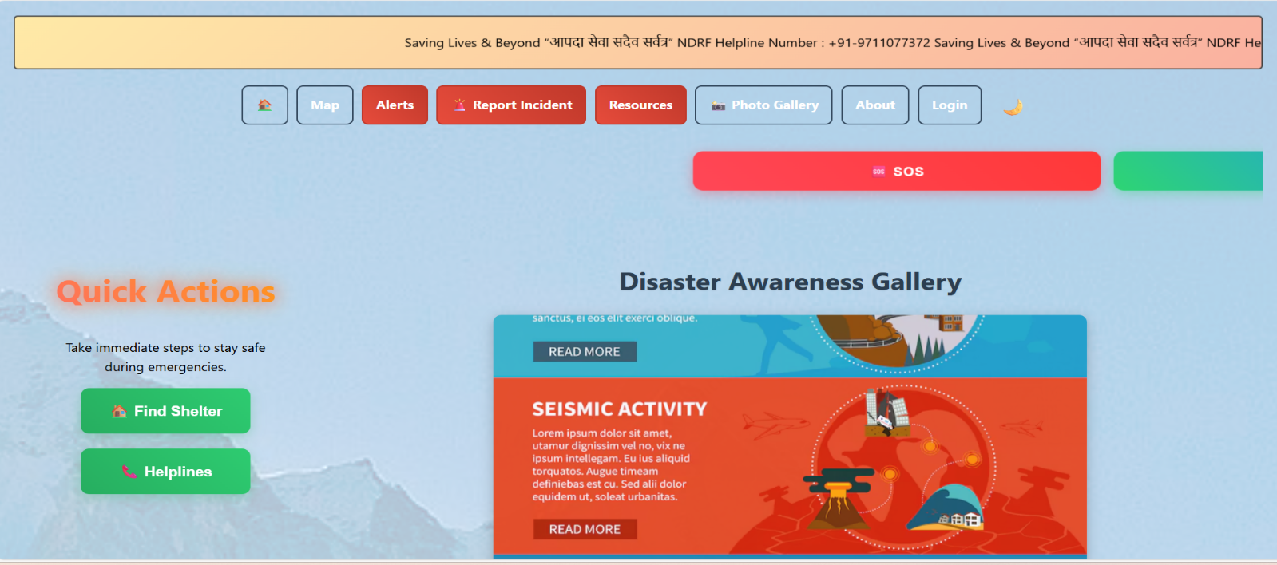

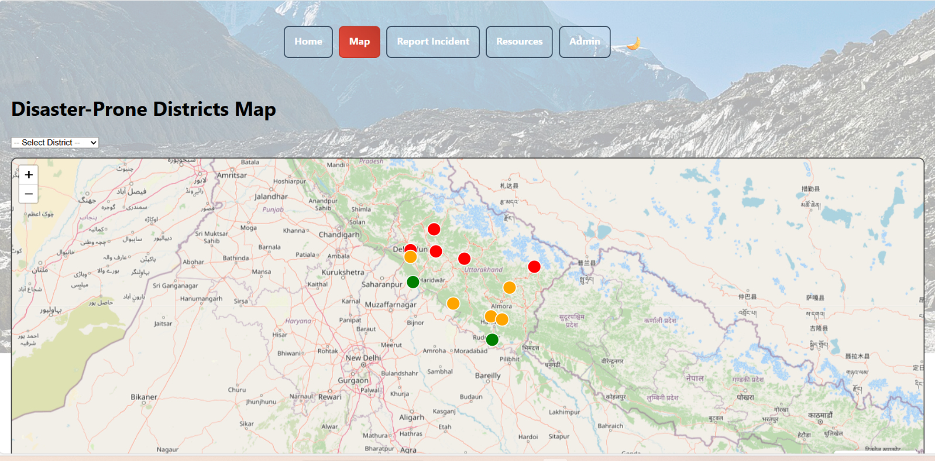

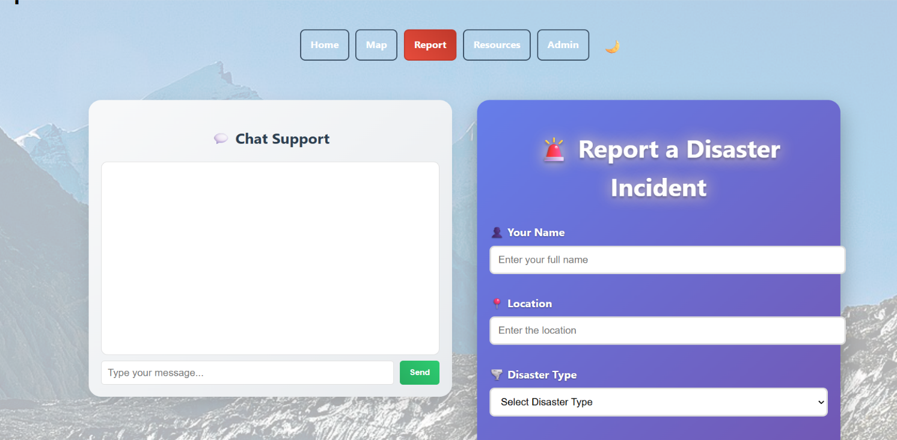

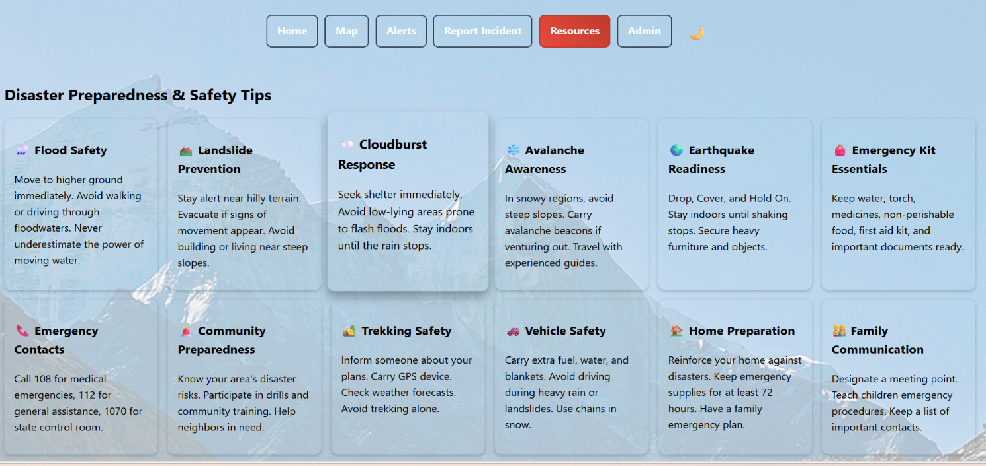

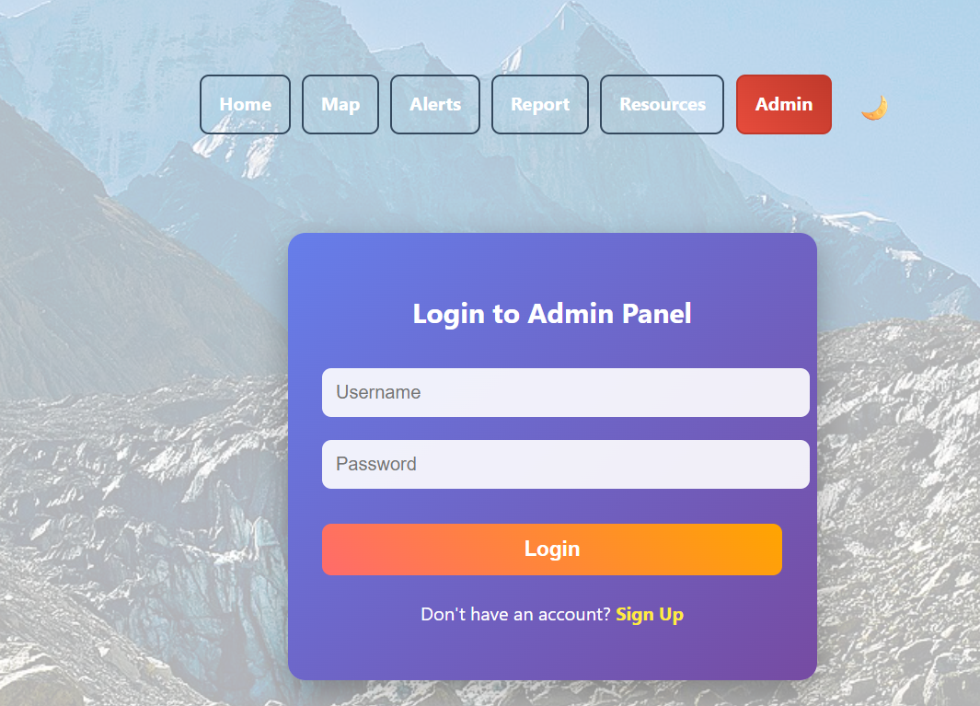
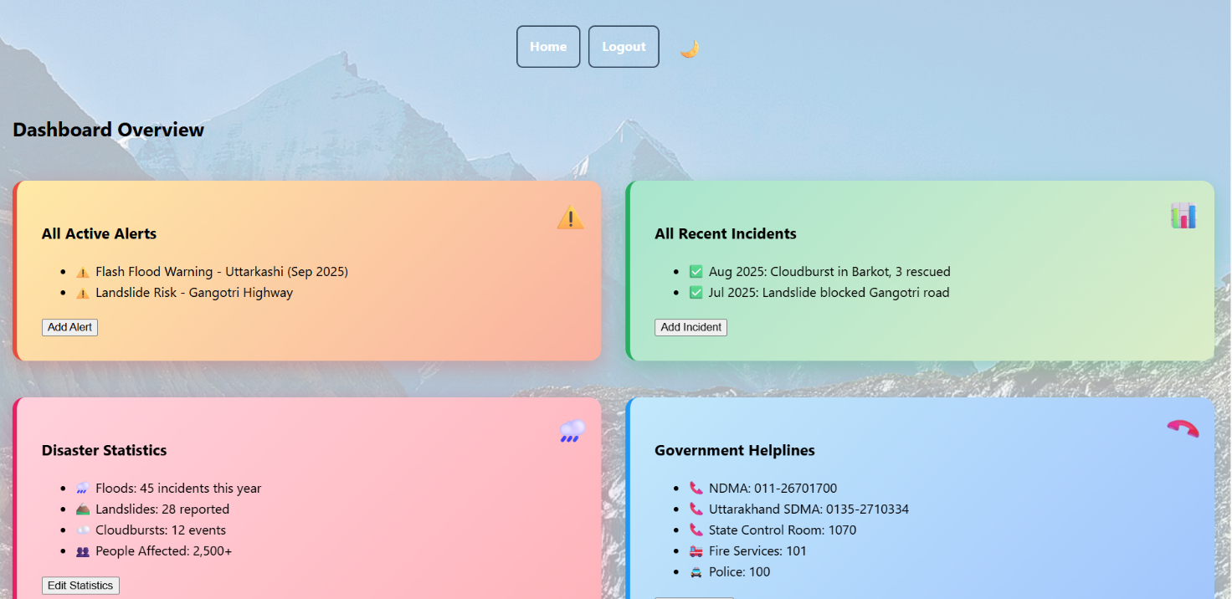

Complete Structure of the Project

Number of Modules and Description:
- User Registration & Login Module
  - Citizens, Admins, and Rescue Teams
- Disaster Detection & Classification Module
  - Inputs from sensors or APIs
- Smart Alert System Module
  - Sends SMS/Email/Push notifications
- Rescue Team Management Module
  - Assigns nearest team using GPS
- Resource Allocation Module
  - Manages food, medicine, equipment
- Help Request Handling Module
  - Citizens request help, tracked by admin
- Data Analytics & Reporting Module
  - Generates daily/weekly/monthly reports

Data Structures Used:
- Arrays, Lists, Maps for storing alerts and resources
- Trees/Graphs for route optimization
- Queues for handling emergency requests
- Database tables for permanent storage

Process Logic of Each Module:
- Input data → process → generate alert → store → notify users → generate report

Testing Process to be Used:
- Unit Testing (Each module)
- Integration Testing (Modules together)
- System Testing
- User Acceptance Testing (UAT)
- Performance Testing

Report Generation (Tentative Content):
- Daily disaster summary
- Area-wise damage reports
- Rescue operations report
- Resource usage report
- Incident history

Problem Statement & Objectives
Natural disasters continue to pose significant threats to communities worldwide, affecting millions of people each year. Despite advancements in technology, many existing disaster management systems still operate on outdated and inefficient frameworks. These conventional approaches rely heavily on manual data collection, human observation, and delayed communication, which leads to slow response times and an increased margin for error. In many regions, there is no integrated system capable of delivering real-time environmental data, generating alerts automatically, and presenting actionable insights to decision-makers. This gap becomes critical during events like floods, landslides, or earthquakes, where even a few minutes of delay can lead to substantial damage and loss of life.
One of the main challenges in current systems is the lack of real-time monitoring. Most disaster-prone areas do not have dedicated sensor networks capable of continuously tracking parameters such as water level, soil moisture, temperature, rainfall, or ground vibration. As a result, authorities are forced to rely on periodic manual checks or reports from local residents. This outdated method limits the ability to anticipate disasters early enough for effective evacuation or mitigation actions.
Another key issue lies in fragmented communication channels. Disaster information often passes through several intermediaries—local authorities, emergency teams, district offices—before reaching the general public. This layered structure introduces significant delays, errors, and inconsistencies. A centralized automated alerting system is essential to eliminate these communication barriers. Furthermore, accessibility remains a major concern. Existing systems rarely provide user-friendly dashboards or multi-platform access, making it difficult for officials and communities to monitor real-time data from remote locations.

Objectives
To address these challenges, the Smart Disaster Management System focuses on the following key objectives:
- To design an IoT-based system for detecting and monitoring disasters: The system integrates multiple sensors with a microcontroller to continuously track environmental parameters in disaster-prone regions.
- To integrate sensors with a cloud server for real-time data transmission: The collected data is processed and stored in a cloud platform to ensure accessibility and reliability even during network disruptions.
- To develop a web-based dashboard for data visualization and alerts: A user-friendly interface displays live readings, graphical trends, historical data, and system alerts to help authorities make informed decisions.
- To automate alert notifications via SMS or Email when danger levels are exceeded: When thresholds are crossed, the system automatically sends instant warnings to officials and residents, reducing response time and improving preparedness.
These objectives guide the overall development of the system and ensure it meets the core requirements of efficiency, reliability, and scalability.

References/ Bibliography
1. M. Natiq et al., “A Disaster Management Framework Using Internet of Things-Based Interconnected Devices,” International Journal of Distributed Sensor Networks,2021.Available: https://onlinelibrary.wiley.com/doi/10.1155/2021/9916440
2. R. Patil and S. Patil, “Smart Disaster Response System using IoT and AI based Decision Making Algorithm,” International Journal for Research in Applied Science & Engineering Technology, April 2025. Available: https://www.ijraset.com/research-paper/smart-disaster-response-system-using-iot-and-ai-based-decision-making-algorithm
3. R. Singh et al., “IoT Based Disaster Alert System,” International Journal of Advanced Research in Science, Communication and Technology, 2025. Available: https://ijarsct.co.in/Paper28183.pdf
4. T. Kurniawan et al., “Sensors on the Internet of Things Systems for Urban Disaster Management,” Frontiers in Built Environment, 2023. Available: https://pmc.ncbi.nlm.nih.gov/articles/PMC10490738/
5. S. Yadav, “Disaster Management System using Internet of Things,” International Journal of Creative Research Thoughts (IJCRT), 2024. Available: https://www.ijcrt.org/papers/IJCRTF020017.pdf
6. N. Agarwal et al., “IOT based Industrial Disaster Management System,” Powertech Journal, Sept. 2024. Available: https://powertechjournal.com/index.php/journal/article/view/827
7. J. Raymond et al., “IoT in Disaster Management: How IoT is Redefining Disaster Relief Strategies,” HashStudioz Blog, 2025. Available: https://www.hashstudioz.com/blog/iot-in-disaster-management-how-iot-is-redefining-disaster-relief-strategies/
8. P. Kumar et al., “Urban Resilience through IoT-Based Disaster Preparedness and Response,” ScienceDirect, 2025. Available:

Future Scope and Limitations

Future Scope:
- Integration with IoT sensors for automatic detection.
- Use of Machine Learning for disaster prediction.
- Mobile application using AI chatbot for emergency help.
- Multi-language alert support for citizens.
- Integration with government disaster management frameworks.
Hardware used: -
  - ArduinoUNO
The Arduino UNO acts as the primary microcontroller and processing unit of the system. It is responsible for reading data from all connected sensors.
  - RainSensor
The rain sensor is used to detect the presence and intensity of rainfall
  - TemperatureSensor
The temperature sensor measures ambient temperature and helps in monitoring heatwaves or abnormal thermal conditions.
  - SoilMoistureSensor
The soil moisture sensor measures the amount of water content in the soil.
  - Wi‑FiModule(ESP8266)
The ESP8266 Wi‑Fi module provides wireless connectivity between the Arduino UNO and the cloud server.
  - PowerSupply
A stable power supply is required to ensure uninterrupted operation of the Arduino, sensors, and Wi‑Fi module.

